License No. of Manufacture Enterprise: Shanghai Drug Supervision Manufacturing License No.20000329
Product Standard No.: Q/NWCP13-2006
Product Register No: Shanghai Food & Drug Supervision Manufacturing License No. 2410781, 2007
Edition 2014-12

BC-J Series

Carbon Dioxide Incubator

INSTRUCTION MANUAL

SHANGHAI BOXUN INDUSTRY & COMMERCE CO.,LTD. MEDICAL EQUIPMENT FACTORY

I Notification
Dear users:
Thank you for purchasing our BC-J80S/BC-J160S series CO₂ Incubator.
For your convenience, please read this instruction manual carefully, and operate and maintain the product according to it, and keep it well.
Since you purchase this product date, Boxun after sale service will work closely with you, no matter what problems in use, please contact us, we will strain every nerve to serve you.

II Marks Introduction

 AC
Protective conductor terminal
Power on
Power off
Caution, Attention, Danger

III Safety precaution
The matters described herein is extremely important, must abide by.
Danger! (The hint implies wrong operation may result in death or serious injury)
- Ensure the reliable grounding.
- Ensure the power plug tight.
- Do NOT pull the power plug during operation.
- Do NOT damage the power line or use the non-specified power line.
- Do NOT connect the power line or use the extension line.
- Loosen the reducing valve before opening cylinder, other it may cause explosion of gas hose because of excessive pressure.
- Do NOT touch plug or power line with wet hands.
- Do NOT put fingers, sticks or other foreign bodies into the air outlet or inlet.
- If any abnormal condition (burning smell etc.), the power plug should be removed immediately to stop the operation, or disconnect the power supply through circuit breaker.
- NO unauthorized repair.
Important! (The hint implies wrong operation may result in injury or property loss)
- Read and understand the instruction manual fully before operation.
- Use an independent power socket.
- Do NOT pull the power plug by pulling the power line.
- Confirm the local power supply voltage before operation.
- When moving the device, keep inclination less than 45 degree.
- Keep the device vertical standstill for 12 hours after installation.
- Any of the following circumstances, the power plug should be removed:
- When open the door of power box.
- When replace the fuse.
- When malfunction occurs and can NOT be normal used.
- When NOT use for a long time.
- When moving.
Notice! (The hint implies wrong operation may affect the normal use and life)
1 Be sure the device is placed on firm ground and keep level condition.
2 The instrument must be kept about 10CM distance away from the wall.
3 Do NOT place the instrument to the stove or direct sunlight.
4 The surface of the instrument can not contact with gasoline, lacquer thinner and other volatile chemicals.
Keep inside and outside of the instrument clean.
5 The instrument will cut the power off when it is over 70℃. Can’t be adjusted by users.
6 Do not turn needle valve. Be sure the pressure of reducing valve around 0.05MPa.
7 Replacement of cylinder when the pressure is under 1KPa. During replacing close the switch first, loosen screw, then remove the reducing valve and install on the cylinder.
8 Fill in water in time the light of water level is on with alarm.
9 Keep the glass door open at less half of minutes until all the gas is out.
10 Do not adjust any part of units in control box.
11 Water-jacket type of CO2 incubator is not allowed to filled in pure water.

IV Introduction

1 Applicable scope
It is vividly used in medical establishment for culture of cell, tissue and bacterial.
2 Product Introduction
This instrument is benchtop of CO₂ Incubator. It is made of powder shell, stainless chamber, heater, valve gear and electronic control unit.(Please see picture below.)
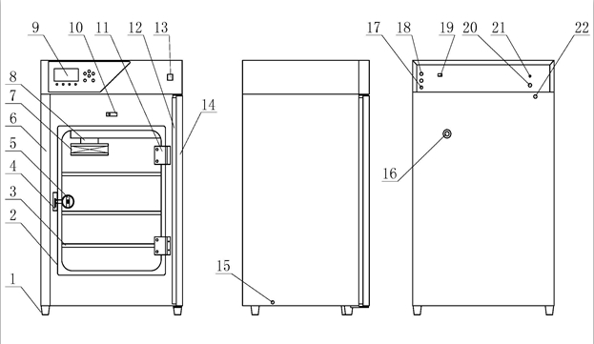

1 Legs 2 Indoor glass 3 Screen plate 4 Buckle
5 Lock group 6 Chamber 7 Filter 8 Impeller casing
9 Display 10 Switch of door 11 hinge 12 Magnetic stripe seal
12 Switch of power 13 Outer door 15 Outlet 16 Test port
17 Power line 18 Fuse tube 19 485 interface 20 Filler
21 CO2 inlet 22 Overflow

3 Operating Principles
Bacterial culturing need to be under certain temperature (36.5℃±5℃) and appropriate concentration of CO2(5%vol). BC series of CO2 incubator generate heat by heating electronic units and water in jacket. Then the temperature of air inside of chamber will be rising and achieve uniform by fan. The temperature control unit which is made of temperature sensor and controller can manage temperature fluctuation inside to keep temp. constantly.
When temperature is under control, inject certain proportion CO2 which is under CO2 concentration control and valve unit. Therefore, BC series of CO2 incubator can control temperature and CO2 concentration and provide a stable and live environment to culture cells.

4 Main Technical Parameters
Model  Parameter | BC-J80-S | BC-J160-S
Temp. range | RT+5℃～60℃
Temp. fluctuation | ≤±0.3℃ (37℃)
Temp. uniformity | ≤±0.5℃(37℃)
Temp. recovery time | ≤30min (37℃)
Humidity Range | ≥93％RH
CO₂ ranger | 0～20%
CO₂ concentration recovery time | Calibration×1.2min
Work ambient | Temp.: 10℃～30℃ Humidity≤70%RH Height ≤2000m
Power supply | AC 220V 50Hz
Power consumption | 600W | 900W
Working zone (mm) | 420×400×550 | 540×490×680
Overall size (mm) | 562×521×960 | 682×611×1090
Volume | 80L | 160L
Optional | One out of three: Printer, GPRS, Computer control

V Installation Requirement
 Please read instructional manual carefully.
Make sure current capacity of socket will more than 10A. Be sure the power line is reliable grounding. Cut the power of when replacing UV lamps.
1. Environment requirement:
a) Ambient temp.: 10℃~30℃; humidity: ≤70%;Height:≤2000m.
b) Avoid strong illumination and heat source, good aeration, and no strong magnetic field around.
2. There is power supply not smaller than 10A and water source around the equipment. The power socket should has reliable ground lead.
3. The instrument must be kept about 10CM distance away from the wall. And place in an aeration-dying room and avoiding directly sunlight.
4. Be sure there are CO2 cylinder and pressure reducing valve. And keep the pressure stable.
5. Check the equipment in good condition, and install as follow steps:
a) Place the equipment on the smooth table or ground, connect power supply.
b) Connect water source and water interface with water pipe (provided by user).
c) Install CO₂ special relief valve on the CO₂ cylinder, and no leakage on the interface. Connect the relief valve output interface and CO₂ input interface on the back of the CO₂ incubator with rubber hose supplied by us which inner diameter is Φ8 and withstand voltage is 0.2MPa , and fasten with impact ring to avoid leakage. Cylinder keep closed temporarily.
d) Loosen the pressure reducing valve before opening.
After above steps finished, the equipment can be used.

ⅤI Transportation
Do not place the device upside down or inclination more the 45 degree during transporting.
Before moving, take everything out of the chamber and let all the water out and cut off power supply.
Must use suitable equipment to carry on during long distance transportation.
It can be manual lifting by several people for short transportation.

VII Use Methods
1. When you use the water-jacketed CO₂ incubator for the first time, the water level indicate light is on with alarm. Turn on the water source switch and fill water into chamber. The water level indicate light will be off and alarm will stop along with the water level heightening. Then turn off the water source and finish affusing.
2. Boot-strap
Connect the power, place the main power switch to “I” and the green light is on.
(1) Adjust the temperature setting value to your need (ex. 37℃), heating light on (green) means it is heating.
(2) Open the CO₂ cylinder after the temperature has reached the setting value (the relief valve should be eased off before open it to avoid the relief valve output pressure is too high to burst the rubber hose), input pressure gauge on the relief valve shows the CO₂ pressure inside the cylinder. Screw the relief valve knob clockwise slowly, and make the relief valve output pressure shows 0.05Mpa and the finger is in the middle of the reticule. Then set the CO₂ concentration (adjusted to 5% before leave factory) on the control panel. CO₂ input indicate light is on, and there is CO₂ into the chamber now. LCD displays the CO₂ concentration value along with the increased concentration. When reach the setting value, the electromagnetically operated valve is cut off, and it is switch to the air and CO₂ entrainment.
(3) It has been adjusted to 5%±0.3% CO₂ concentration before leave factory.
(4) When temperature reaches the setting value, the fluctuation is less than ±0.5℃, and CO₂ concentration meets the requirement, you can process the cell cultivate. Put inside the water plate and enable the humidity meet the requirement, natural evaporation can reach 95% normally.
(5) You should operate according to the requirements above and check the pollution inner before cultivate when you use the equipment for the first time or use it after long time no use.
3. Shut down
Close the CO₂ cylinder before shut down, place the CO₂ input switch at “0”, and then cut off the power. If it won’t be used for a long time, you should take out the water plate and swab down the chamber. In the state of placing the CO₂ switch at “0”, after electrifying for two hours when the chamber temperature is 37℃ to ensure dryness inner, cut off the power.

4.Setting Method of Temperature and CO₂
1) Sketch Map of Control Panel

▲
Set
Move
▲

2) Definition of buttons and indicate lights
1) “Set” button: Temperature, concentration setting button;
2) “▽” button: in setting state, press the button to decrease the number;
3) “△” button: in setting state, press the button to increase the number;
4) “Move” button: in setting state, press the button to switch and amend setting value;
5) “Silencing” button: press the button to silencing when buzzer sounds or enter the inner parameters setting mode;
6) “Sterilization” button: sterilization switch button;
7) “Heating” light: the indicate light is on when heating;
8) “Fast charge” light: the indicate light is on when charge CO2 fast;
9) “Slow charge” light: the indicate light is on when charge CO2 slowly;
10) “Sterilization” light: the indicate light is on when the UV light is on.
3) Operation
Set of temperature and CO2 concentration
Turn on the power and initializing for 3 sec, it enters normal running state. Press the SET button and controller will enter the user set state. Press it again and exit the set state, and setting value is saved automatically.
User set as follow table
name | (range) initial value
Temperature set | (0.0～60.0)  30.0℃
Concentration set | (0.0～20.0)  5.0%
5. User parameters set
Keep the SET button pressed for 3 sec, control panel displays “Please input password”, set the password to 3 and press the SET button again to enter user parameters set state. Keep it press for 3 sec after parameters amended, the controller will exit the state and return to normal running state.
User parameters set as follow table
Parameter name | Notes of parameters function | （range）  initial value
Ratio | Adjust time ratio effect. Decrease the value to accelerate heating output. | (0.3～20.0)  10.0
Temperature departure alarm | When measured temp.>=Setting temp.+ temp. departure alarm value, heating output is cut with beeps. | (0.0～5.0)  1.0
Concentration departure alarm | When measured concentration value>=setting concentration value+ concentration departure alarm value, fast charge or slow charge is cut with beeps. | (0.0～3.0)  1.0
Temperature amend | Amend the error occurs when temp. sensor is measuring  Temp. amend value = actual temp. value – measured temperature value | (-9.9～9.9)  0.0
Concentration zero amend | Amend the error occurs when concentration sensor (zero) is measuring.  Concentration zero amend value = actual concentration value – measured concentration value | (-3.0～0.0)  0.0
Concentration full range amend | Amend the error occurs when concentration sensor (setting point) is measuring.  Concentration full range amend value =1000*(actual concentration value – measured concentration value)/ measured concentration value | (-999～999)  0
Temp. Amend | Amend the error occurs to test humidity sensor  Values = HUMI PV-current testing valve | (-30～30)  0
Equipment No. | The equipment address number | (0～32)  1
6.Observe chamber temp., door temp. and water temp.
Keep the SET button pressed for 3 sec, control panel displays “Please input password”, set the password to 9 and press the SET button again to enter temp. observe state. Keep it press for 3 sec after temp. observed, the controller will exit the state and return to normal running state.
7. Factory parameters set
Keep the SET button pressed for 3 sec, control panel displays “Please input password”, set the password to 18 and press the SET button again to enter factory parameters set state. Keep it press for 3 sec after parameters set, the controller will exit the state and return to normal running state.
Factory parameters set as follow table
Parameter name | Notes of parameters function | （range）  initial value
Fast charge valve value | When measured CO2 concentration value＜concentration set value + fast charge valve value, fast charge electromagnetic valve is opened, then slow charge electromagnetic valve is opened. | (-3.0～0.0)  -1.0
Door temp. set error | Door temp. set value = temp. set value + door temp. set error value | (-5.0～5.0)  1.0
Door temp. amend | Amend the error occurs when temp. sensor is measuring.  Temp. amend value = actual door temp. value – measured door temperature value | (-9.9～9.9)  0.0
Concentration radio | Adjust time scale | (0.1～20)  5.0
Integral time | Adjust integral function. | （0～999）  50
Derivative time | Adjust derivative time. | （0～999）  100
Control cycle | Air entraining cycle. | (1～100)  10
In parameters set state, if no key is pressed in 30 sec, the controller will exit the set state automatically without parameter saved.
8. Alarm indicator and disposal
Alarm indicator | Disposal methods
Normal | Controller is running normally.
System malfunction | Controller malfunction. All heating and charge output are cut with beeps.
Chamber temp. malfunction | Chamber temp. measure error. All heating and charge output are cut with beeps.
Door temp. malfunction | Door temp. measure error. All heating and charge output are cut with beeps.
Water temp. malfunction | Water temp. measure error. All heating and charge output are cut with beeps.
Concentration malfunction | Concentration measure error. All heating and charge output are cut with beeps.
Lack of water | Heating output is cut with beeps.
Over temperature | Heating output is cut with beeps.
Over concentration | Charge output is cut with beeps.
Lack of concentration | Charge output is cut with beeps.
Door is opened | All heating and charge output are cut, fan output is closed without beeps.

9. Definition of lack of concentration:
- When concentration set value≤8.0%, if concentration measured value＜concentration set value - 0.5% lasts for 15 min, controller will indicate lack of concentration alarm.
- When 8.0%＜concentration set value≤15.0%, if concentration measured value＜concentration set value - 0.5% lasts for 30 min, controller will indicate lack of concentration alarm.
- When 15.0%＜concentration set value≤20.0, if concentration measured value＜concentration set value - 0.5% lasts for 45 min, controller will indicate lack of concentration alarm.
10.Other functions
- Water level control: when low water level alarms, heating output is cut automatically;
- Gating: when door switch is open, fan and heating and CO2 charge are cut automatically;
- Fault treatment: when sensor open circuit or short circuit occurs or temperature exceeds measure upper limit, it indicates sensor malfunction, heating output is cut automatically with beeps, press the Silencing button to deaden the noise. Check the sensor and connection carefully if above conditions occurs.

VIII Trouble Shooting
Please contact professional help you to repair or contact us, do not take part at will.
Please follow the details below to repair the device.
If you can’t, please contact us and give us the model, number to us. We will offer service.

Symptom | Diagnose | Method
Sensor alarm | ·Check temperature sensor, model No.PT100  ·CO2 concentration abnormal | ·Replacing yourself after contacting distributors or factor
Temp. can’t reach setting value | ·Check heating pipe  ·Check relay | ·Please contact us if heating pipe is broken.  ·Also contact us if relay need to be replacing
No display | ·Check the power line can reach 220V  ·Check the switch can electrify.  ·Check fuse | ·Close the power switch  ·Turn switch on  ·Replace fuse
Unstable CO2 supply | ·Check if the pressure of cylinder is low over.  ·Check if the pressure supple is fit.  ·Check reducing valve is workable | ·Replacing gas cylinder  ·Adjust or replace reducing valve  ·Replace reducing valve
The device has one year of warranty (except human errors damage). It will be charged over a year.

IX Maintenance
1 Please follow the details below for current maintenance.
Daily | - Check the connection of power supply and water supply.  - Check parameters of testing everyday.  - Keep the device and environment clean.
Monthly | - Clean water tank, and fill in clean water.  - Sterilize the interface of chamber.

- Device Cleaning
Use neutral detergent to clean and water after. Keep inside of chamber dry. Do not use benzene medical solvents.
Please follow the steps below:
a) take out of shelf and foot
b) clean water tank;
c) place shelf and foot
- Sterilizing the device
Do not us sodium chloride solvent to clean device.
Clean interface of chamber with 75% soaked gauze, and use distilled water to clean again, then use gauze to keep it dry.
If all the methods above are not workable, please use lactic acid fumigation way. Close doors and windows for one week after fumigation. Keep workers away from the room. And use 75% alcohol to sterilize even including the ground. At last use UV light.

X Instruction of RS-232/RS-485 mode adapter
- Standard serial interface for transformation must be required during Data Telecommunication between computers under different standard serial interfaces or externals or intelligent instruments for convenience. The standard compatibility of RS-232, RS-485 is the transformation from single-ended signal of RS-232 to balanced differential signals of RS-485.

- RS-485:
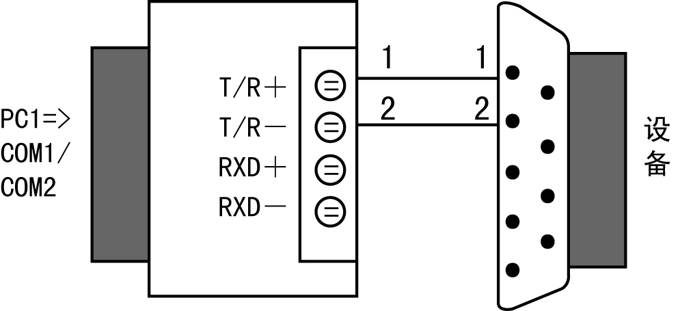

- RS-485:
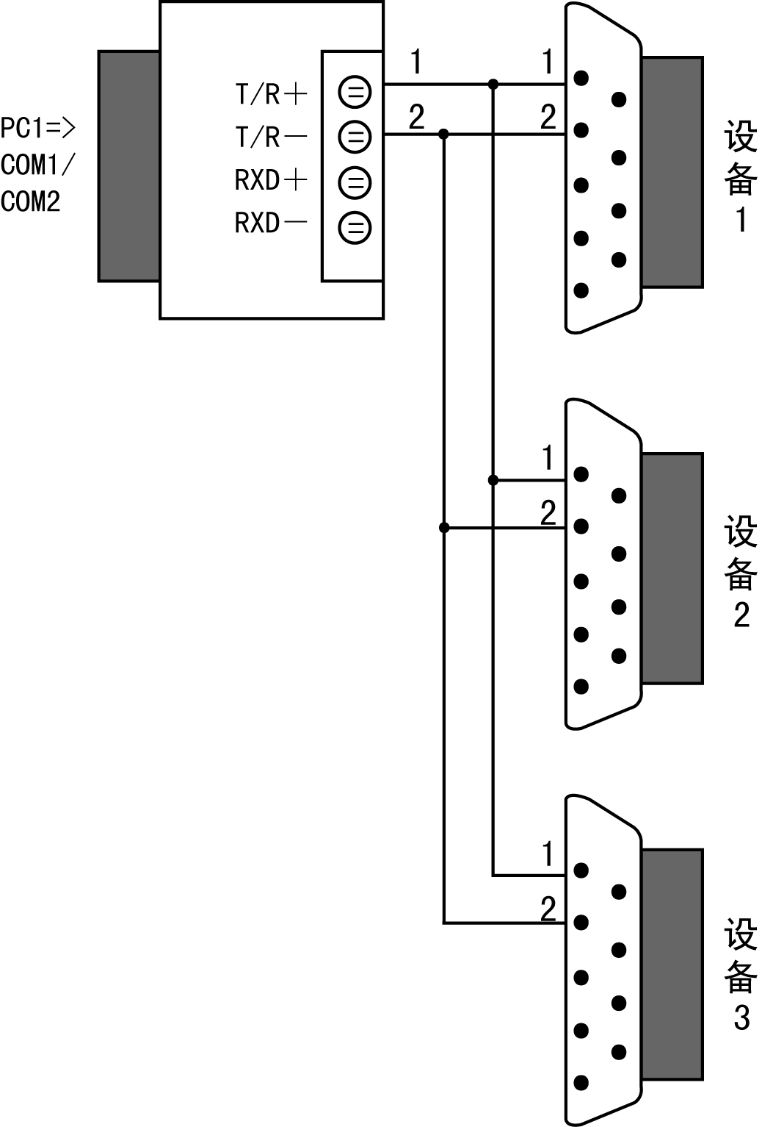

- Fault and Solution
I. Fault in telecommunication
- Check the interface connection of RS-232;
- Check the output interface connection of RS-485;
- Check the connection of terminal.
II. Date Loss or Error
Check date rate and format of DCE.

X Main Components List
No. | Name | Model & Size | Quantity | Remarks
1 | Heater | AC220V 300W | 1 | 80-S
1 | Heater | AC220V 600W | 2 | 160-S
2 | Fan | J238-7242 AC220V | 1
3 | Fuse seat | BF015 | 2
4 | Fuse | F6A 250V | 2 | Φ5×20
5 | Switch with light | R2 10A 250V | 1
6 | Magnetic Valve | WTB-2R-1/4UFH 24VDC | 1
7 | Temp. Sensor | PT100 | 3
8 | Humidity Sensor | Condenser | 1
9 | CO2 Sensor | Infrared Lamp | 1
10 | UV light | AC:220V /8W | 1
11 | Temperature Switch | KSD301 | 1 | AC:250V 5A



SHANGHAI BOXUN INDUSTRY & COMMERCE CO., Ltd.
MEDICAL EQUIPMENT FACTORY

Headquarters Address：Rome 909, No.198 North Zhongshan Road, Shanghai, China
Telephone：021-56980111 Fax：021-56303876
Sales Department：021-56980111 transfer to extension

Register Address：No.28 Zhongqiang Road, Songjiang District, Shanghai, China
Production Address：No.28 Zhongqiang Road, Songjiang District, Shanghai, China
Switcboard：021-57866102 Fax：021-57866198
Customer Service Tele： 021-57866322 021-57866248
Customer Service Fax：021-57866155
Postcode：201607

Website：www.boxun.com.cn
E-mail：bx99123@163.com

